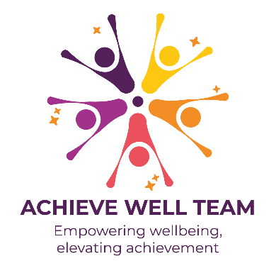

Achieve Well Foundation Awards Action Plan

Benchmarks | Criteria (delete as appropriate) | Actions | Lead person | Timescale | Completed
1. Whole school ethos, modelling and practice around health and wellbeing | - There is a clear vision for health and wellbeing that is promoted by governors and school leaders and reflected in strategies, policies and practice that are regularly monitored and evaluated  - The school physical environment promotes health and wellbeing  - The wider curriculum supports children’s learning around health & wellbeing  - The school provides opportunities for children to make healthy choices  - The school creates an environment of respect and inclusivity by promoting behaviours that celebrate diversity and fostering a sense of belonging across the entire community
2. Provision meets the needs of pupils | - An annual health and wellbeing survey or consultation is carried out to establish areas of need  - There are accessible opportunities for children to share their views and opinions about health and wellbeing support and education on a regular basis  - The school uses internal data to inform their planning and practice  - The needs of specific groups are identified and actions  - Provision and practice are informed by local and national evidence-based research around the needs of children
3. A comprehensive planned PSHE programme | - A named lead has responsibility, time and resources allocated to plan and evaluate the impact of PSHE  - PSHE has high status within the school  - The content of PSHE reflects the Nottingham healthy child vision, children’s needs, statutory requirements, evidence and good practice  - PSHE is delivered safely in a trauma informed manner with an emphasis on accessibility, inclusion and active learning  - Learning in PSHE is routinely assessed and the programme monitored and evaluated to ensure it is having the intended impact
4. Application of Learning within and outside of school | - The school provides a range of clubs relevant to health and wellbeing that are well attended by a broad range of children, these could be before or after school  - The school provides opportunities for children to take up leadership roles related to health and wellbeing  - The school signposts to and actively supports children to access local opportunities focused on health and wellbeing  - The school signposts to and/or provides holiday programmes for children  - All children are encouraged and supported to use their health and wellbeing knowledge and skills in a practical way
5. A safe and supportive environment for children and adults | - Children and adults are signposted to relevant and needs-led health and wellbeing support as and when appropriate  - Bullying, harmful behaviours and discrimination are effectively addressed and actively challenged  - There is embedded pastoral support that all children can access and specialist support onsite  - There are strong links and relevant information sharing between pastoral and safeguarding colleagues  - Provision for support meets the needs of all children
6. Learning from Networks & Training | - Attendance at relevant local networks and sharing of good practice with other colleagues and schools  - The school makes use of links with professional bodies and agencies  - A regular assessment is carried out to identify the training needs of staff around health and wellbeing  - All staff receive relevant training based on their identified needs to support the wellbeing of children  - Health and wellbeing training and discussion, informed by data and insight, is part of staff meetings and/or inset on a regular basis
7. Involving parents and carers in the school’s provision of health and wellbeing | - Opportunities are provided for parents and carers to learn more about health and wellbeing, particularly those with greater barriers to involvement  - Parents and carers are signposted to sources of support around health and wellbeing  - Parents and carers are engaged in children’s learning around health and wellbeing  - The voice of parents and carers is reflected in school policy and provision around health and wellbeing  - Opportunities are highlighted for parents and carers to improve their own health and wellbeing

